FOR IMMEDIATE RELEASE

Zonta International announces new board members
[OAK BROOK, ILLINOIS, 8 July 2022]— Zonta International, a leading global organization building a better world for women and girls, is pleased to announce its vice president Fernanda Gallo Freschi
Elected by the voting members at the Zonta International 65th Convention in Hamburg, Germany, Gallo Freschi was inducted on 28 June and she will serve as the vice president of Zonta International and the Zonta Foundation for Women for the next two years.
“In a nutshell, I envision Zonta International as a climate-friendly, inclusive, cohesive, strong community that builds a better life for women and girls, under every sky”
Fernanda Gallo Freschi, born in Asti, Italy and member of the Zonta Club of Milano Sant’Ambrogio, is the first Italian to serve in this position in our organization; a second generation Zontian, she previously served as international director, governor, and in various other leadership roles at the district and club levels.
Professionally, Fernanda is an engineer with an international research background, currently a senior independent consultant responsible for project management on environment, workplace health and safety and energy management systems for industrial entities.

The 2022-2024 Zonta International and Zonta Foundation for Women Boards also include President Ute Scholz, President-Elect Salla Tuominen, Treasurer Souella Cumming and directors Annika Bränström, Reneé Coppock, Anne-Marie French Cudjoe, Monika Geise, Teresa Lin, Brittany Vaughan and Sandra Venn-Brown.
About the organization: Zonta International (www.zonta.org) is a leading global organization of professionals building a better world for women and girls. In 1919, a small group of founders in Buffalo, New York, had a vision to help all women realize greater equality. Today, more than 27,000 members in 62 countries work together to make gender equality a worldwide reality for women and girls. Since 1923, Zonta International has provided more than US$46.3 million to empower women and girls and expand their access to education, health care, economic opportunities, and safe living conditions.

Contact:
Megan Radavich
Assistant Executive Director, Programs & Advocacy
Zonta International
Phone: +1.630.928.1400
Email: pr@zonta.org
www.zonta.org

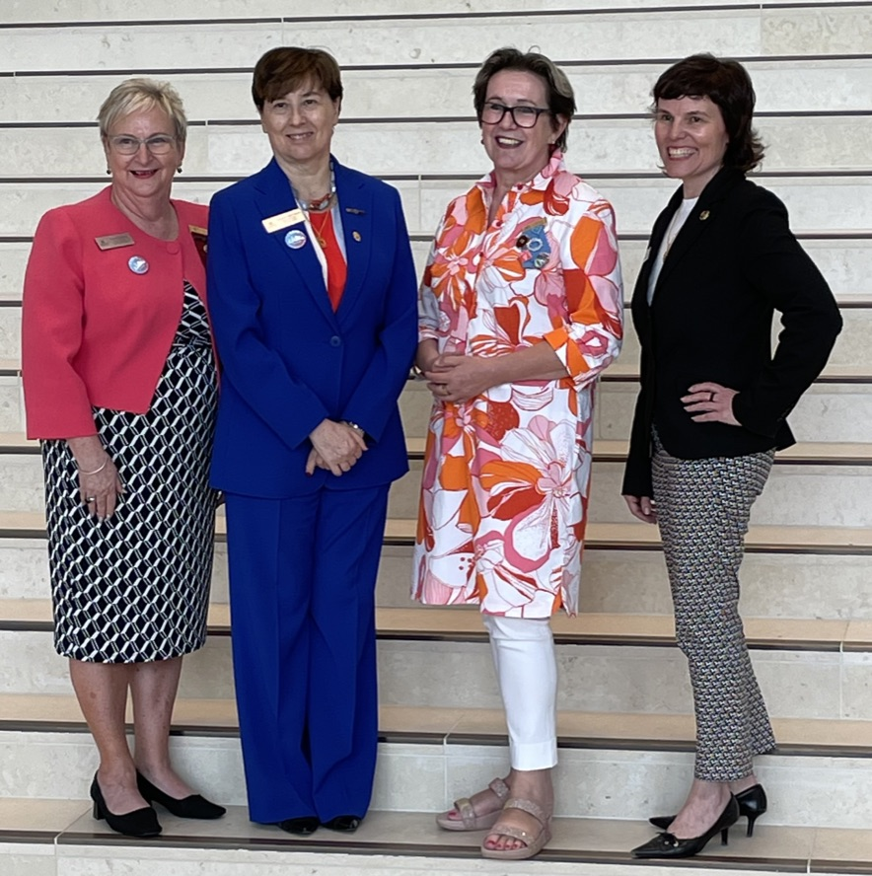
From Left to right, the Zonta executive board 2022-24:
Treasurer Souella Cumming (NZ), VicePresident Fernanda Gallo Freschi (I), President Ute Scholz (D), President elect for 2024-26 Salla Tuominen (FI)

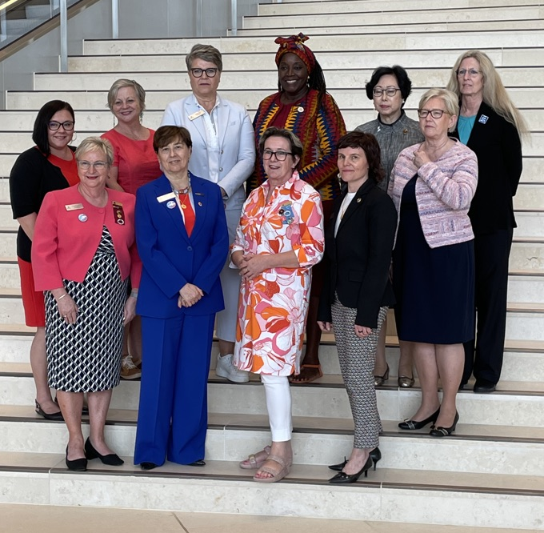
From Left to right, in first row:
Treasurer Souella Cumming (NZ), VicePresident Fernanda Gallo Freschi (I), President Ute Scholz (D), President elect for 2024-26 Salla Tuominen (FI)
Second row: the 7 international directors

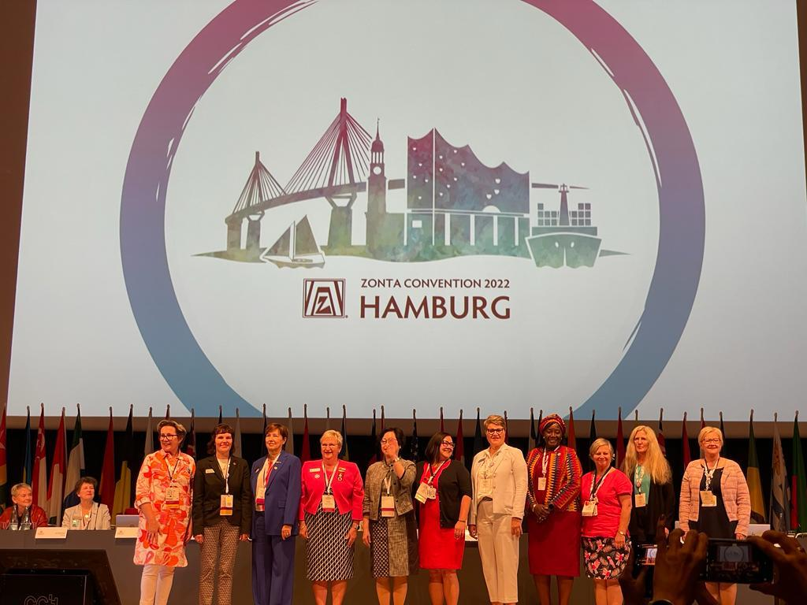
The 2022-2024 elected international board on stage for installation

